1. **Agenda:**
   1. How SpringBoot uses Buildpack to generate docker images.
2. 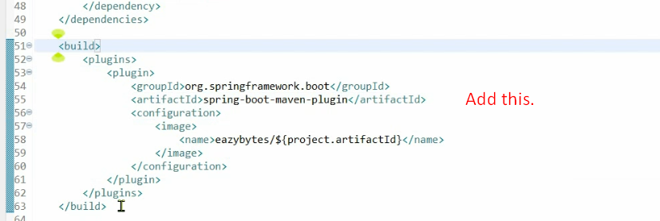  
   **Above**: <name>eazybytes/${project.artifactId} where eazybytes is my Docker ID.
3. 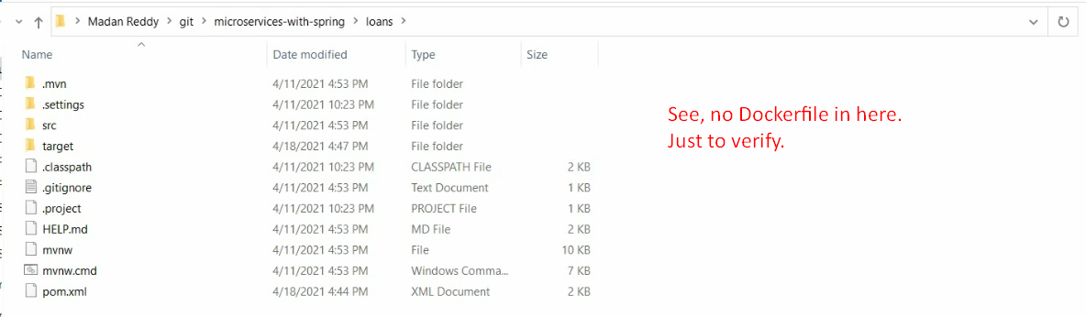
4. 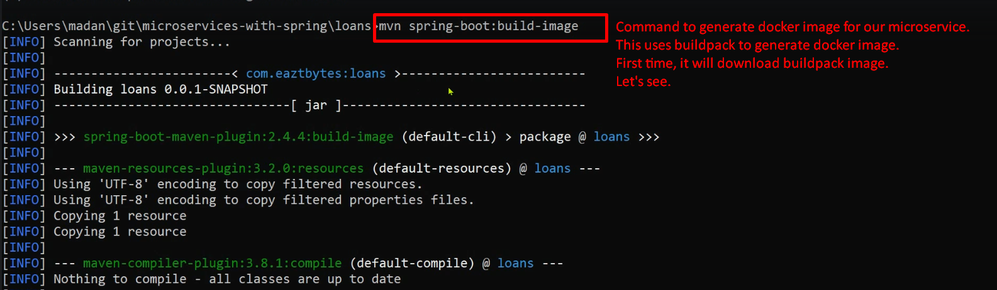**NOTE**: Before creating docker image, it will check all the compilation and validations and performs test cases.
5. 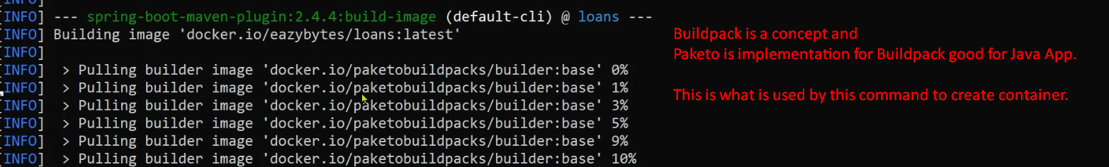
6. 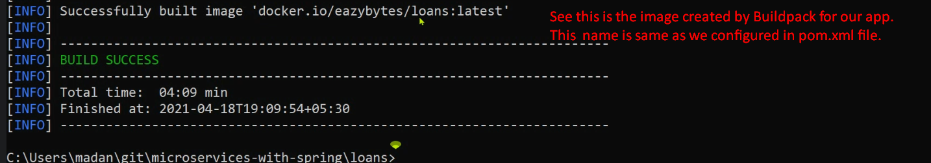
7. 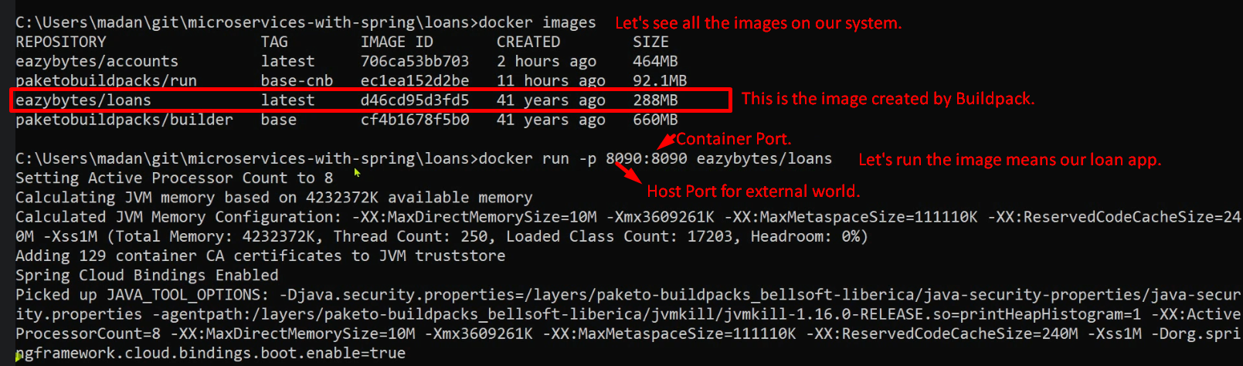
8. 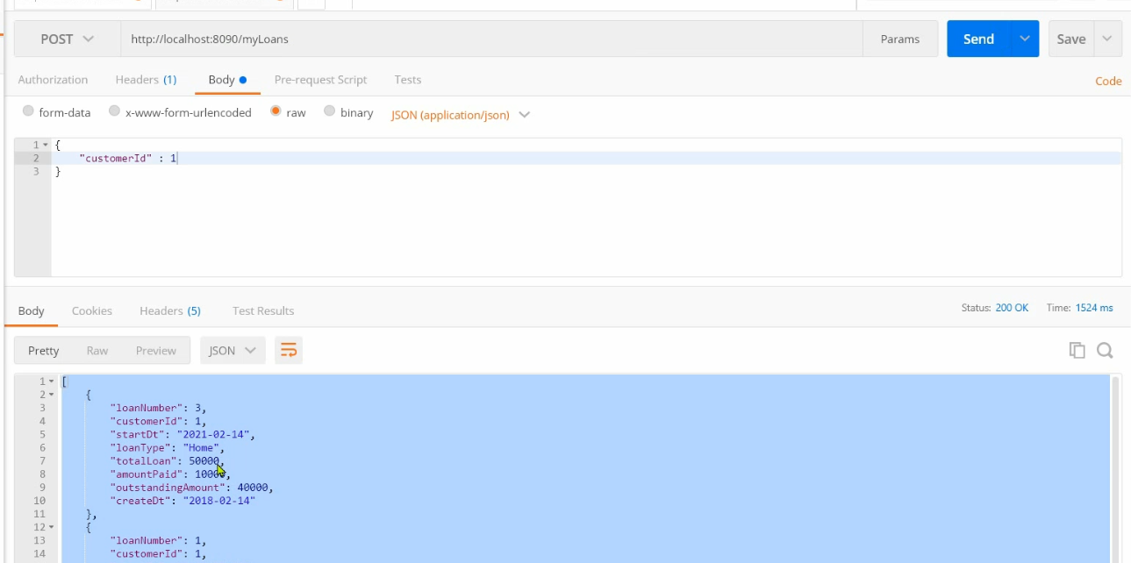
9. 